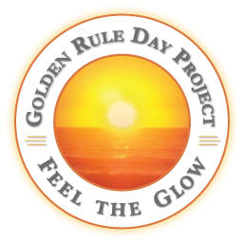

FOR IMMEDIATE RELEASE CONTACT: Angela Coppola, 760-431-2781

GOLDEN RULE PROJECT
ANNOUNCES WINNERS OF SILK SCARF DESIGN CONTEST
TO INSPIRE WORLD PEACE
LA COSTA, CA – Sacred Silks founder Angela Coppola, with her business partner Amy McQuillan, started a non-profit, the Golden Rule Project in July of last year with an international contest to design a silk scarf inspired by the Golden Rules from 11 world religions. Their goal is to promote a world consciousness inspired by the Golden Rule through a line of products carrying the message that will be a constant reminder to all.
The judges were Fashion Directors at the nation’s top design Schools.

First prize winner, Katherine Barron from Savannah, Georgia and a graduate of the Savannah College of Art and Design was awarded the $5,000 first prize. For her design she chose the golden rule from the Yeruba Nigerian religion…” One going to take a pointed stick to pinch a baby bird, should first try it on himself to feel how it hurts.”

Artist Comment: "In his mouth the baby bird holds the pointed stick used to pinch him. His left wing is an abstract pink ribbon (the pink ribbon of peace). Surrounding him are the words of the Nigerian Golden Rule. In the middle of the design is a gold/yellow square to symbolize the Golden Rule. My concept was to create a beautiful design that would convey the message."

Second prize winner, William Psinka, a San Diego advertising professional, was awarded $2,500. Third prize winner, Sarah Crystal from Plano, Texas was awarded $1,000.
The Golden Rule Project is a unique non-profit in that it will generate much of its revenue by creating, through design contests, a brand of merchandise with the Golden Rule theme for the designs The merchandise will then be sold on its website and through retail stores.
A percentage of the profits will go to organizations working to make a contribution to world peace. The beneficiaries of the first contest product sales are Alliance for a New Humanity – Founding Member, Deepak Chopra; Born This Way Foundation – Founder, Lady Gaga; The Peace Alliance – Founding Member, Marianne Williamson; United Religions Initiative – Founder, Bishop William Swing.
The slogan of the Golden Rule Project says it all: “World Peace Begins With Us”…one person at a time. www.GoldenRuleDay.net.
#####

